Linux Basics Assignment

**Instructions**

**In-Depth Lab: Mastering Basic Commands and Familiarity with the Command-Line Interface**

**Part 1: Introduction to the Command-Line Interface**

* Step 1: Opening the Terminal
  + Learn how to open the terminal in your Linux distribution.
  + For Ubuntu, press Ctrl+Alt+T or search for "Terminal" in the applications menu.
  + Ensure each participant can open their terminal window.

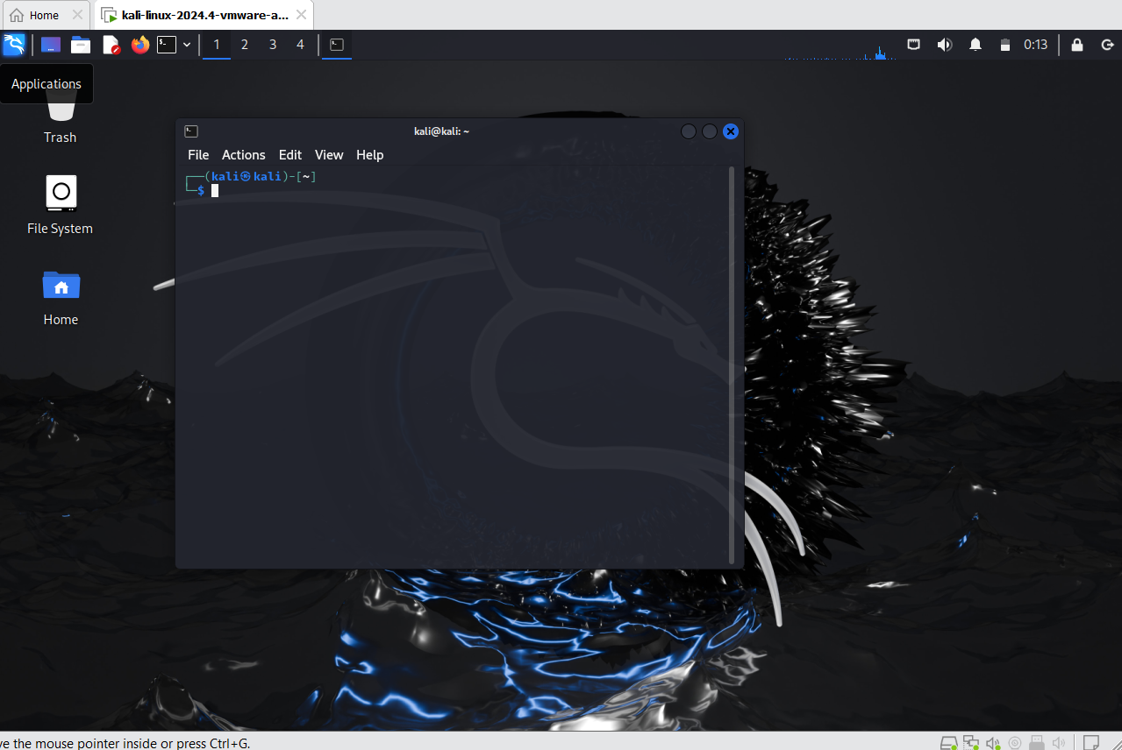

* Step 2: Understanding the Command-Line Environment
  + Discuss the anatomy of the command prompt.
    - Anatomy of the Command Prompt: The command prompt typically appears as:
      * username@hostname:current_directory$
        + username: The name of the current user.
        + hostname: The name of the computer.
        + current_directory: The directory you are currently in.
        + $: Indicates a standard user prompt (use # for root user).

The command prompt provides essential context for every command you type. Understanding each part helps identify which user account is active, the system you're working on, and your current location in the file system. This is crucial when managing multiple sessions or troubleshooting.

* + Explain basic navigation such as how to view the current directory, change directories, and list directory contents.
    - Basic Navigation:
      * View the current directory:
        + pwd
        + This command prints the current working directory.

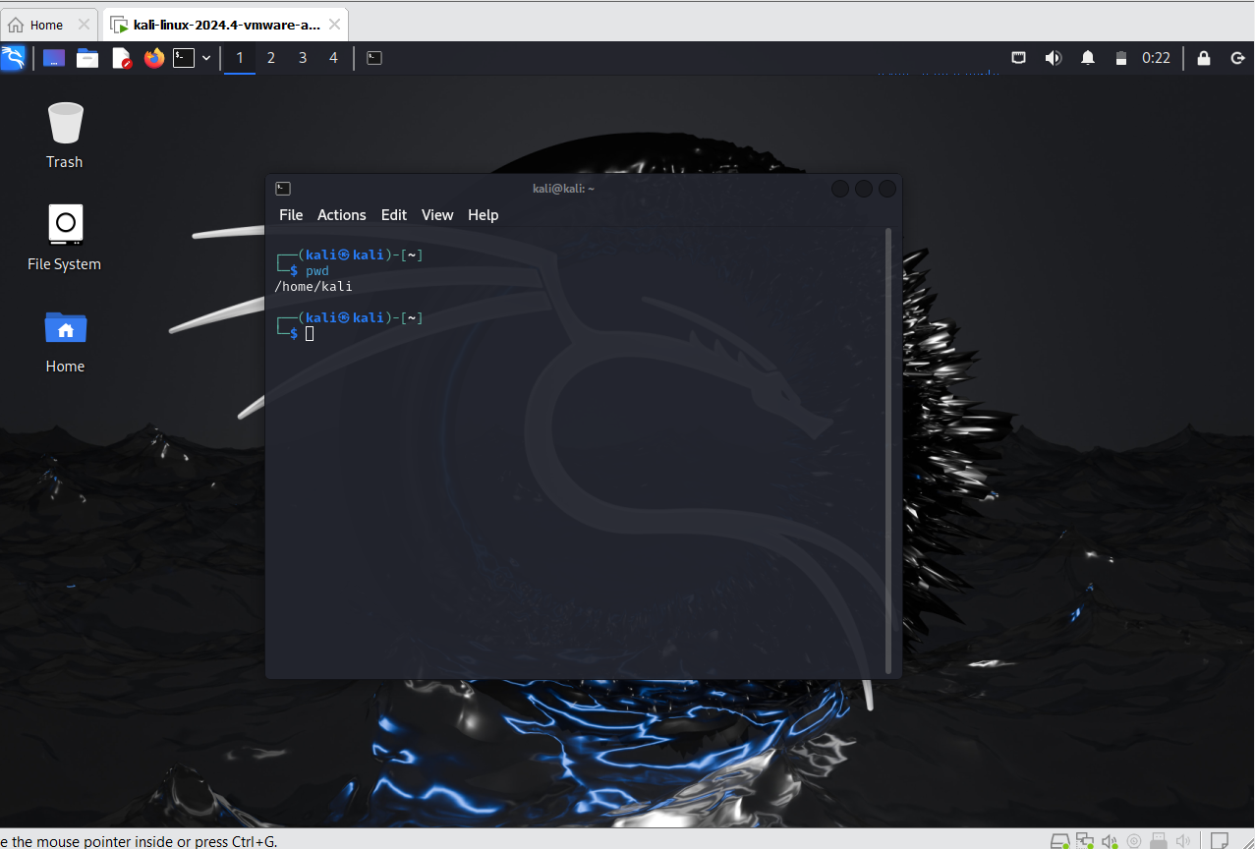

* + - * Change directories:
        + cd directory_name
        + Use cd .. to move up one directory level, and cd ~ to return to the home directory.

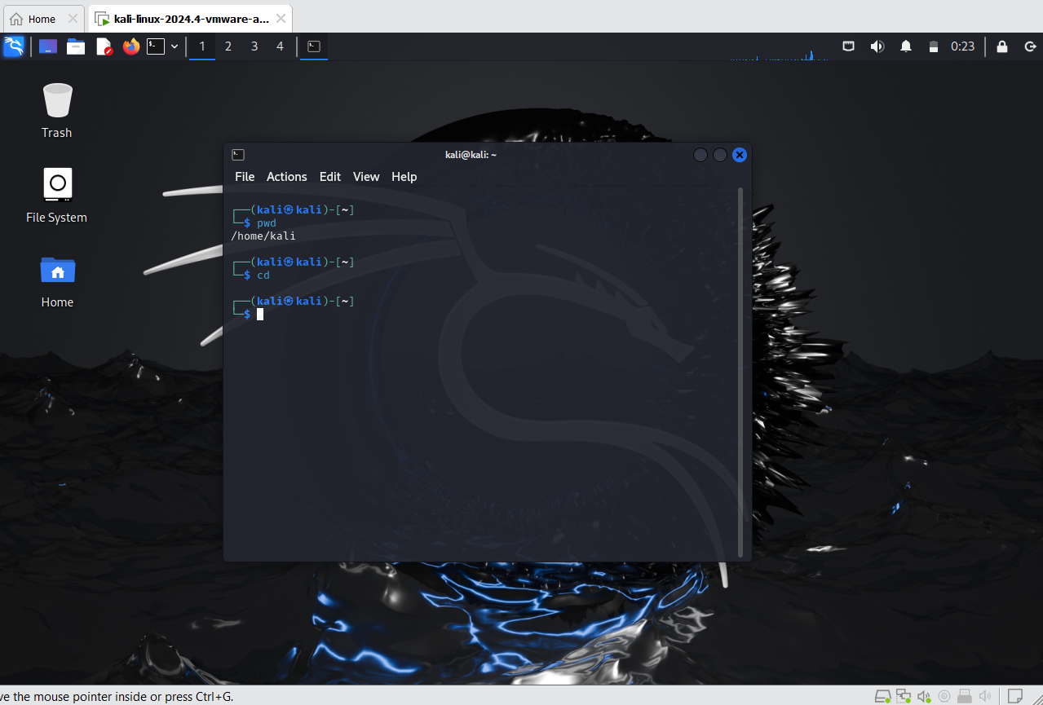

* + - * List directory contents:
        + ls
        + Add options like ls -l for detailed listing and ls -a to show hidden files.

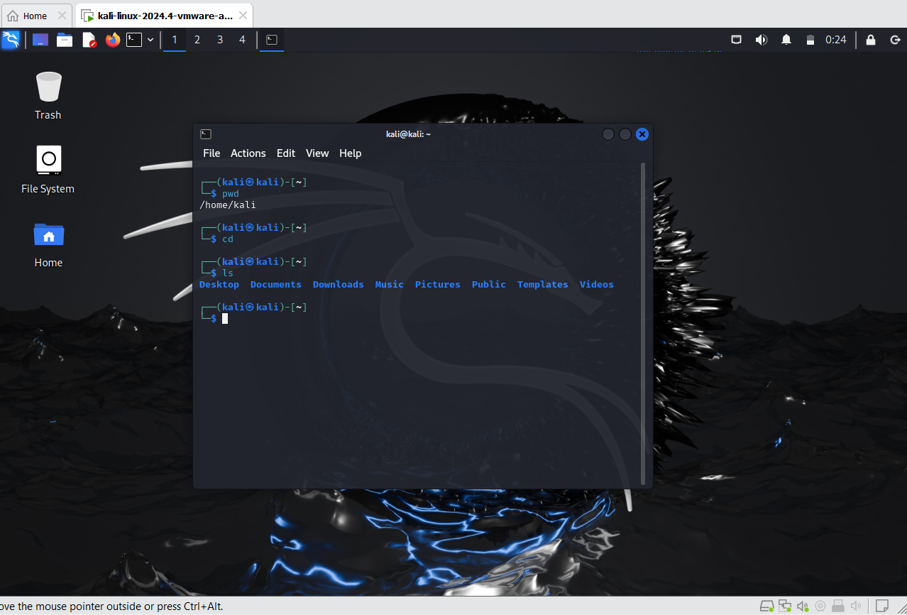

**Part 2: Basic File System Navigation**

* Step 3: Navigating Directories
  + Learn and practice basic navigation commands:
    - pwd (print working directory)
    - cd (change directory)
    - ls (list directory contents)
  + Practice changing to different directories using cd and then return to the home directory.

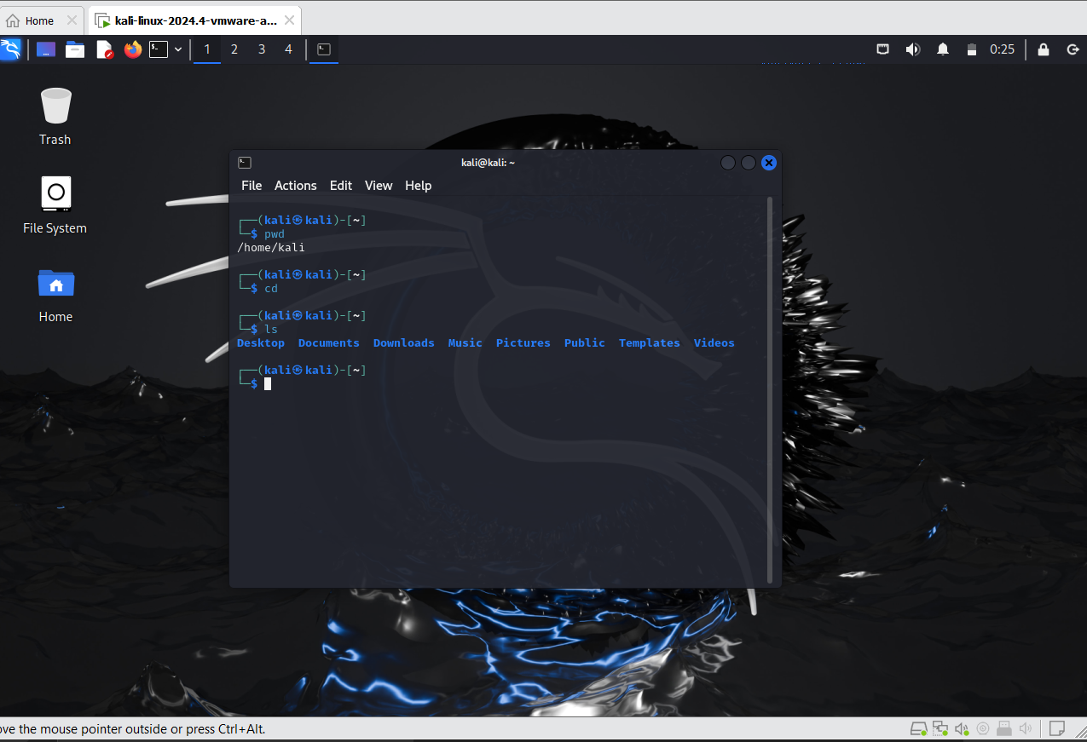

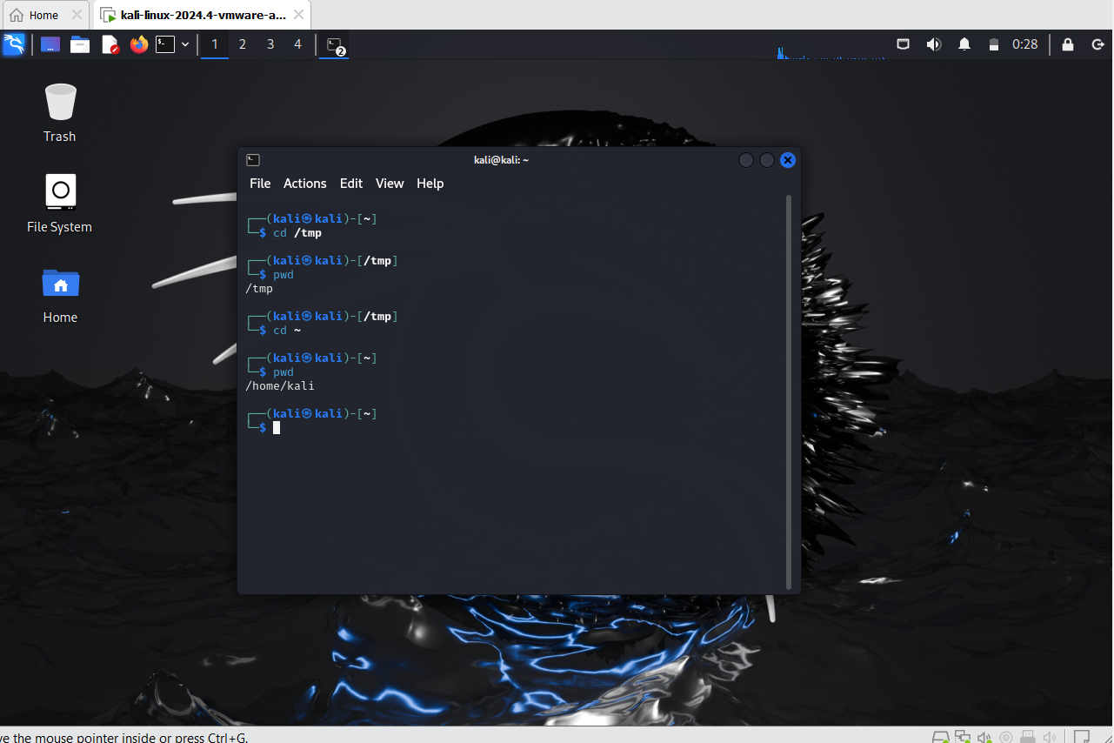

* Step 4: Creating and Managing Files and Directories
  + Understand and practice creating files and directories:
    - mkdir (make directory)
    - touch (create a new file)

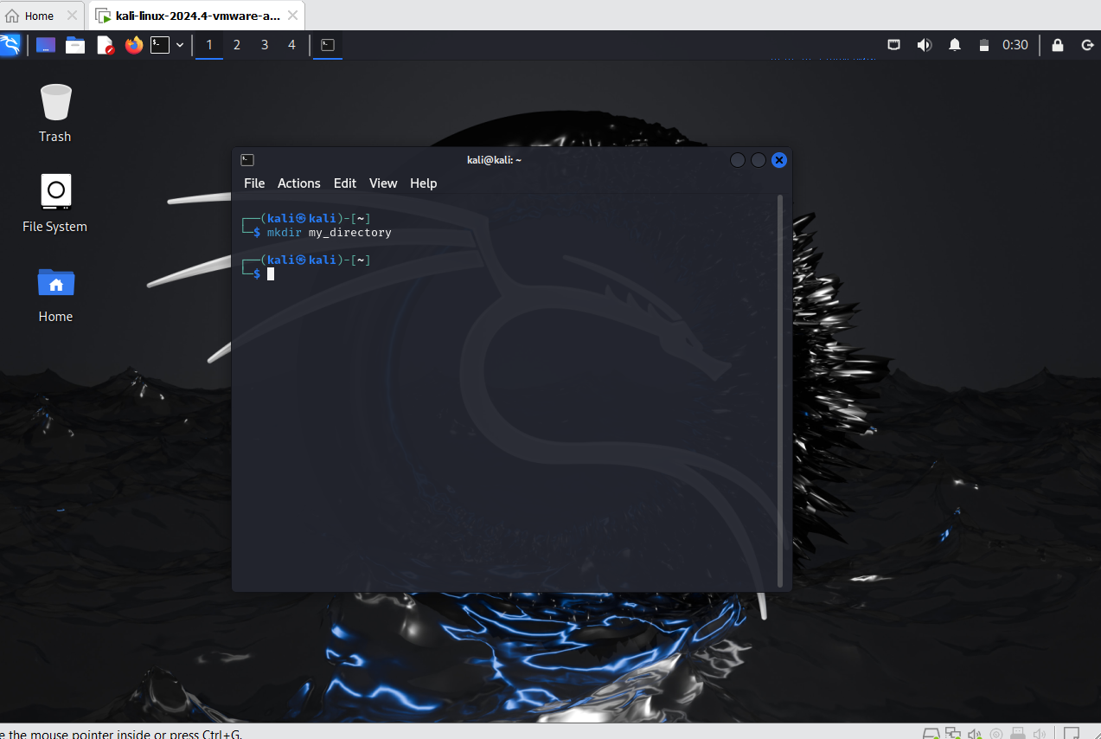

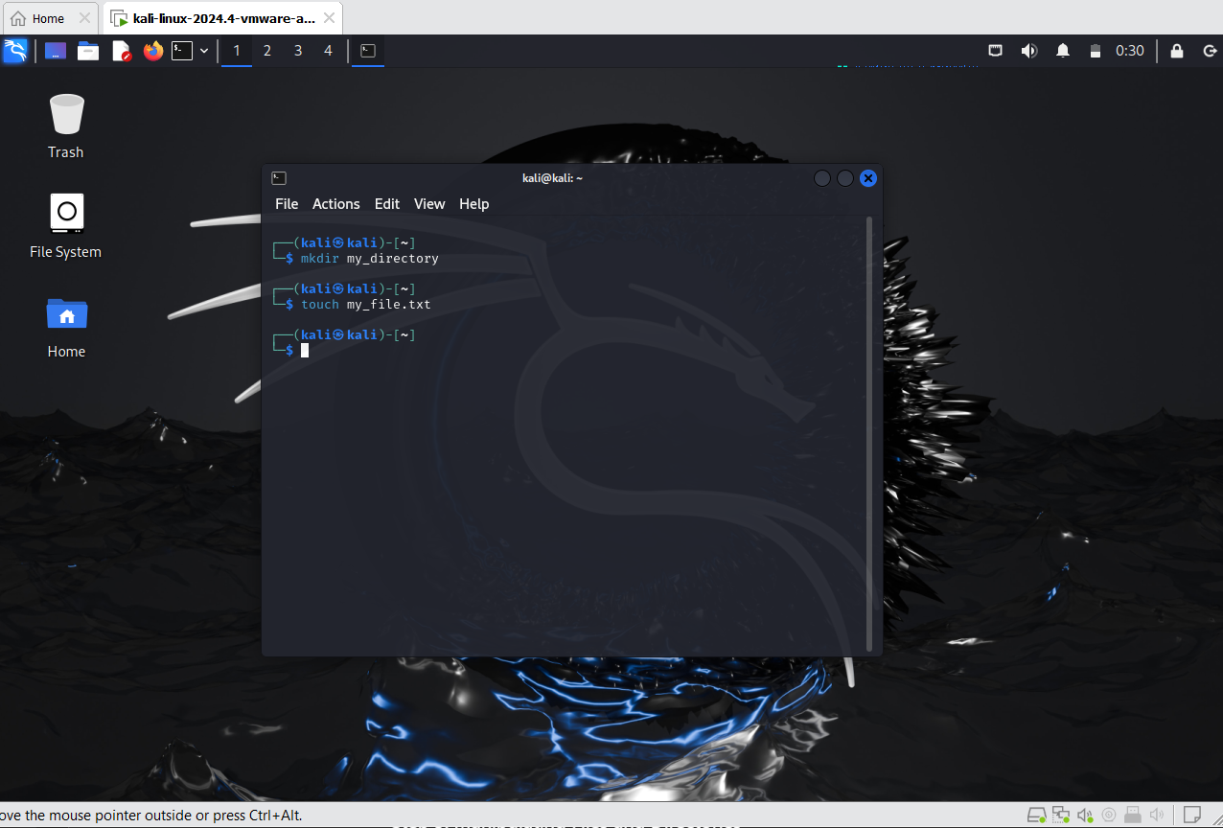

* + Create a new directory and several files within that directory.
  + Learn how to delete files and directories:
    - rm (remove files)
    - rmdir (remove directories)
    - rm -r (remove directories and their contents)

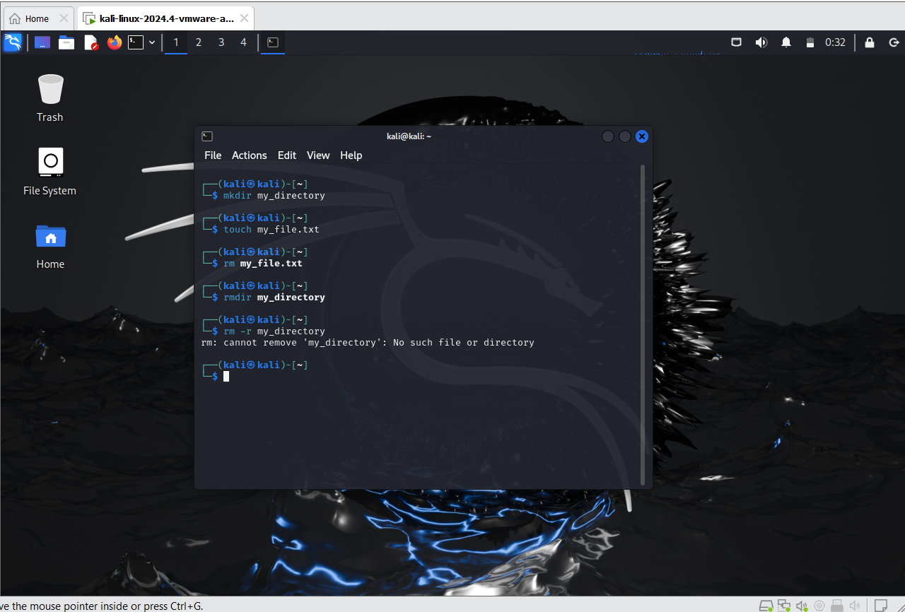

**Part 3: Working with Files and Directories**

* Step 5: Manipulating Files and Directories
  + Practice moving and renaming files:
    - mv (move or rename files)
  + Rename a file, then move it to a different directory.
  + Learn to copy files and directories:
    - cp (copy files or directories)
  + Copy files within a directory and between directories.

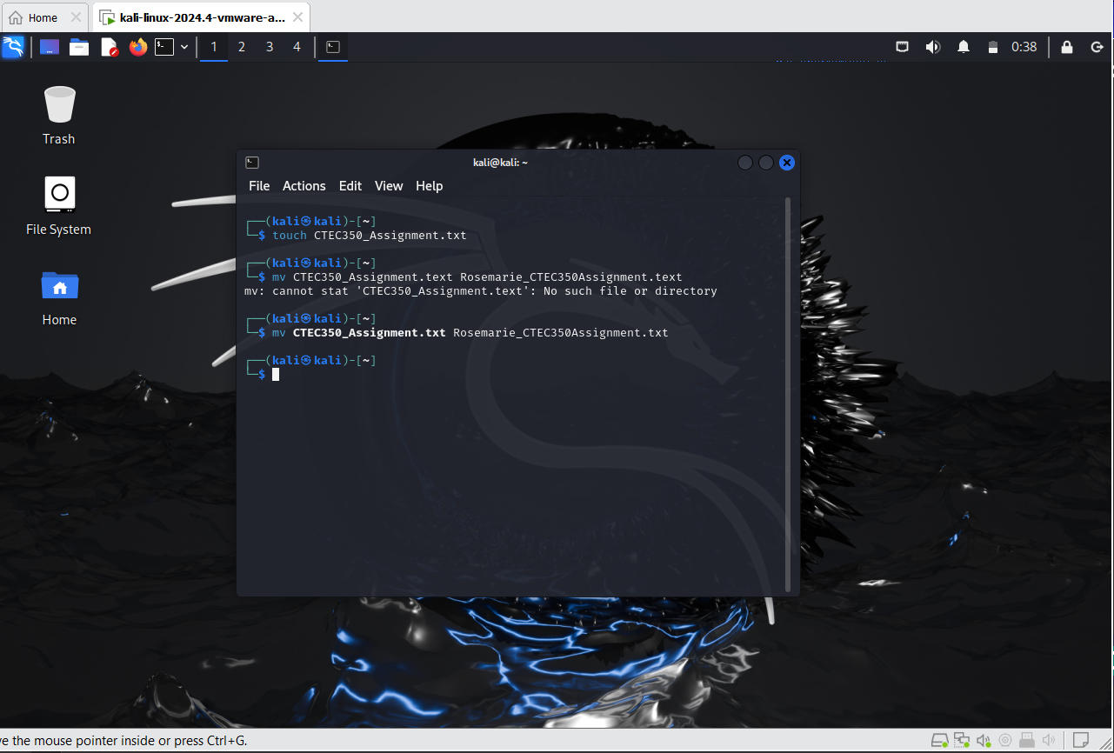

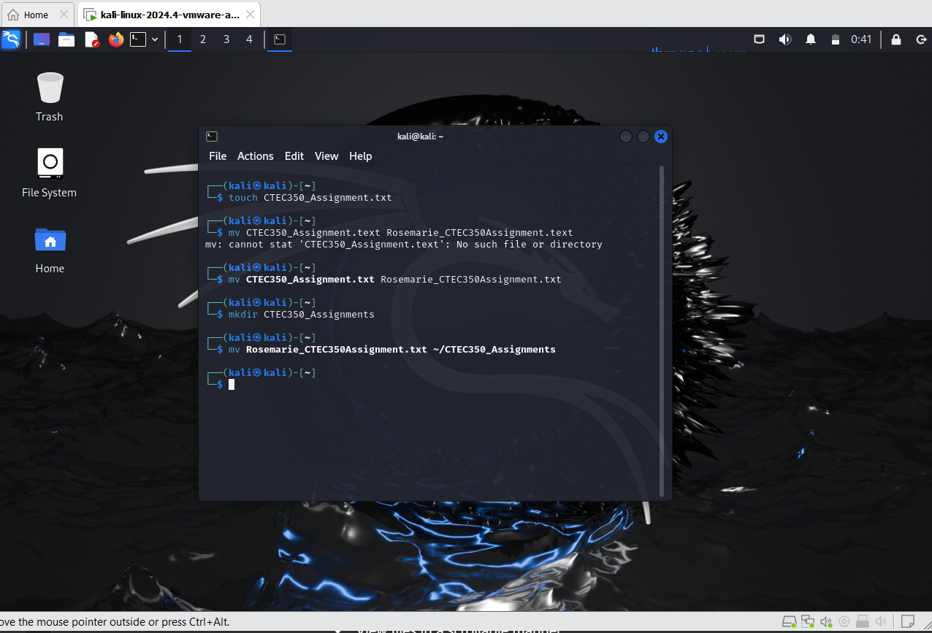

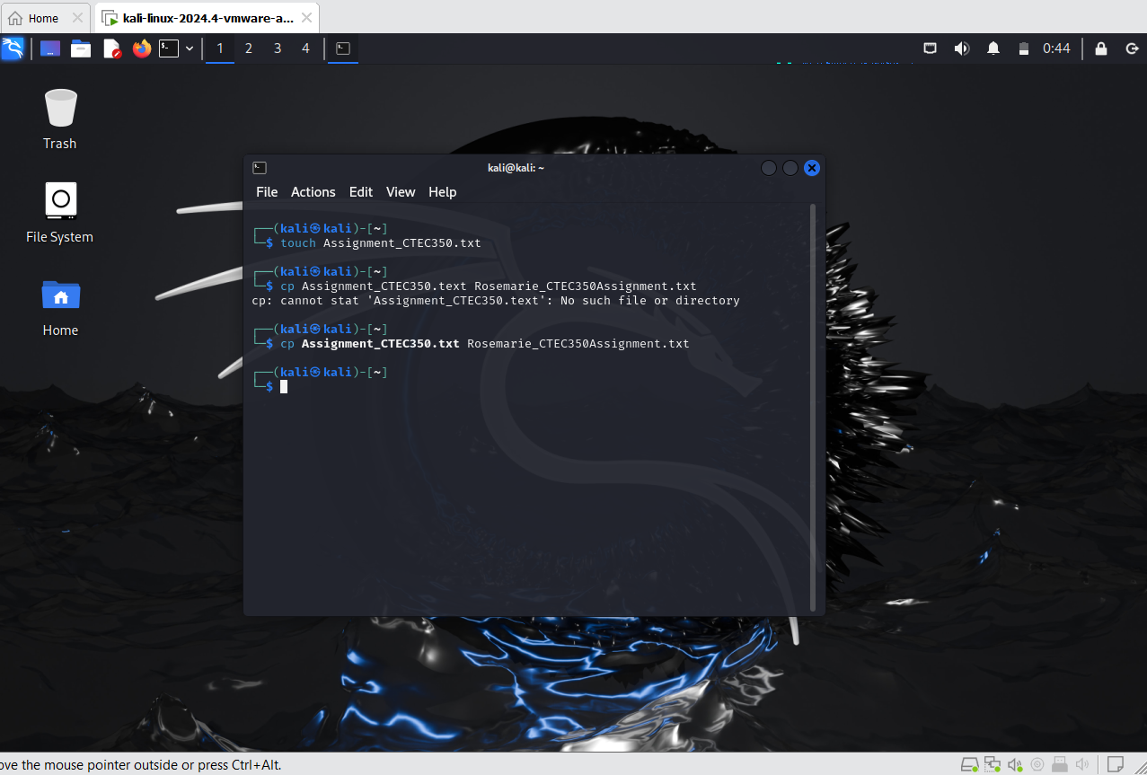

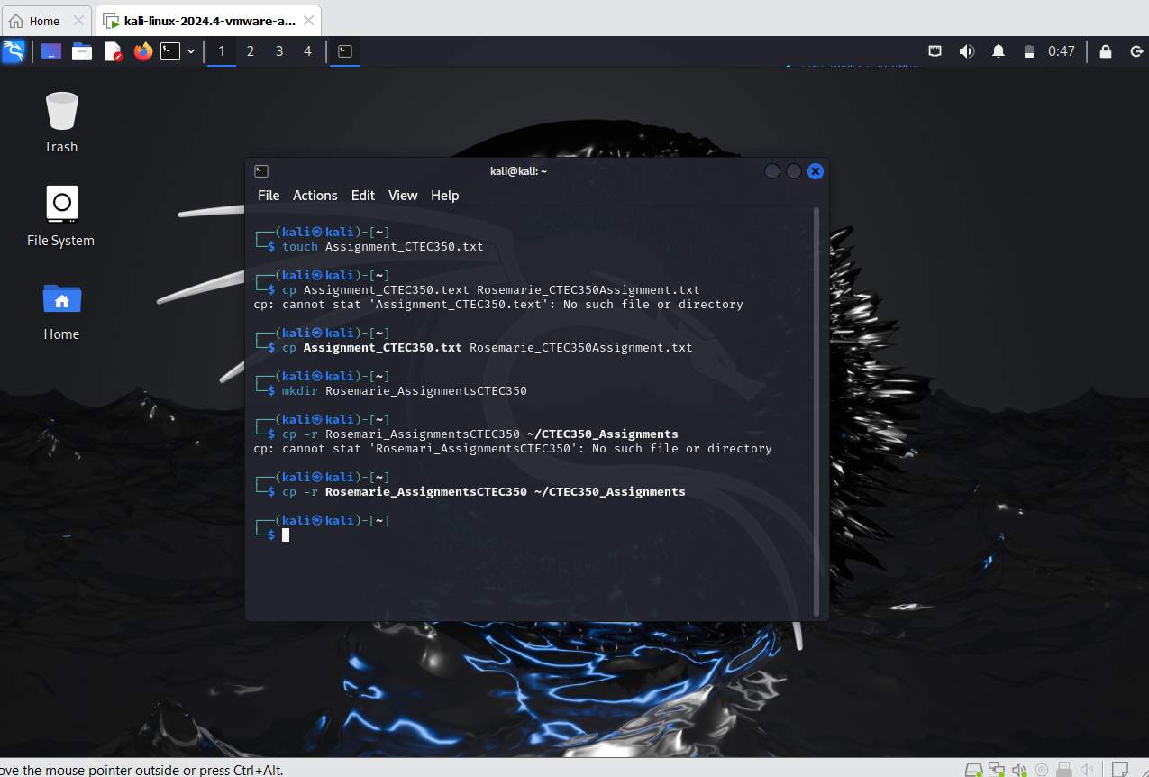

* Step 6: Manipulating Files and Directories
  + Practice moving and renaming files:
    - mv (move or rename files)
  + Rename a file, then move it to a different directory.
  + Learn to copy files and directories:
    - cp (copy files or directories)
  + Copy files within a directory and between directories.









* New Step 7: Viewing and Editing Files
  + Introduce basic file viewing commands:
    - cat (concatenate and display files)
    - more and less (view files in a scrollable manner)
  + Open a file using cat, then practice navigating long files with more and less.
  + Edit files using a basic text editor:
  + Introduce nano as a beginner-friendly text editor.
  + Open, edit, and save changes to a file using nano.

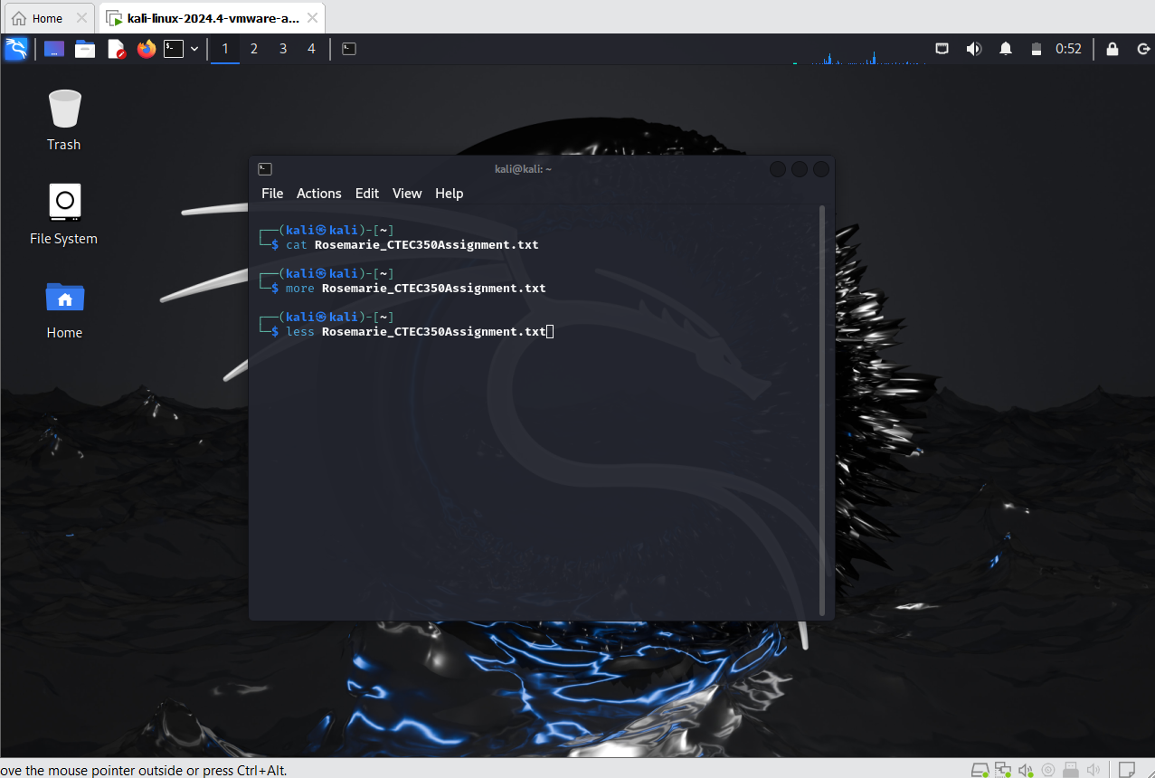

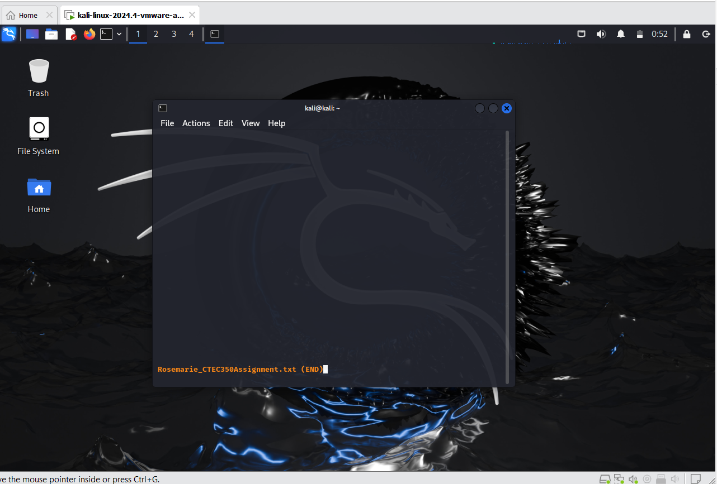

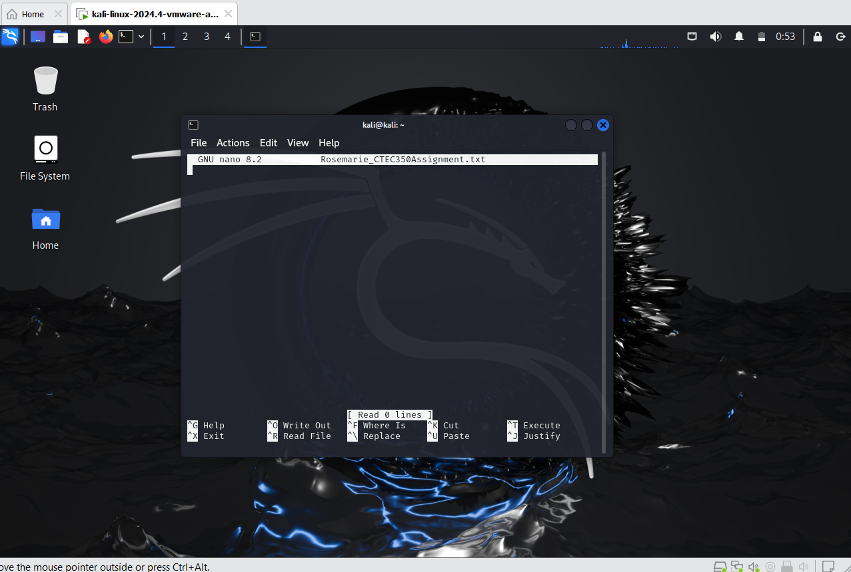

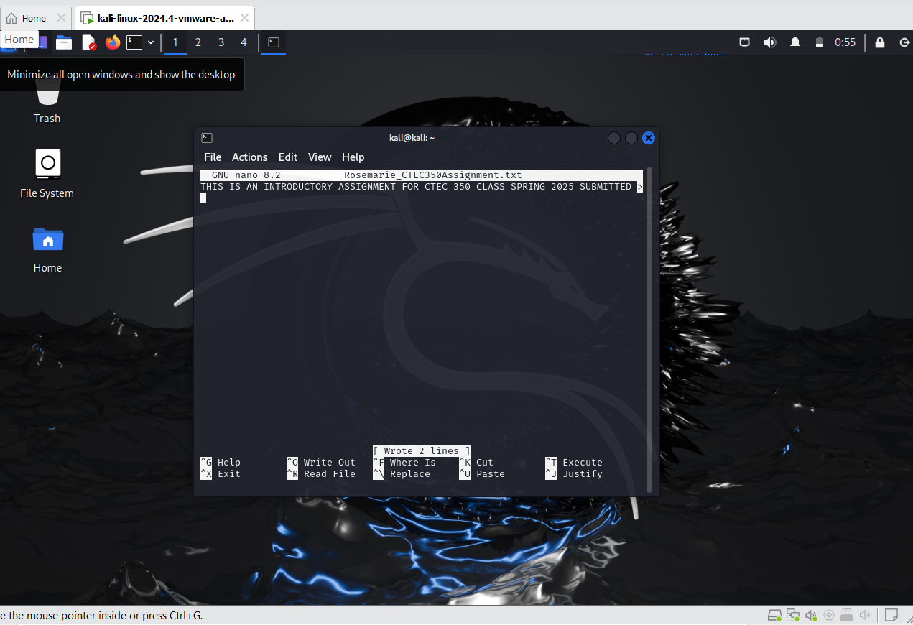

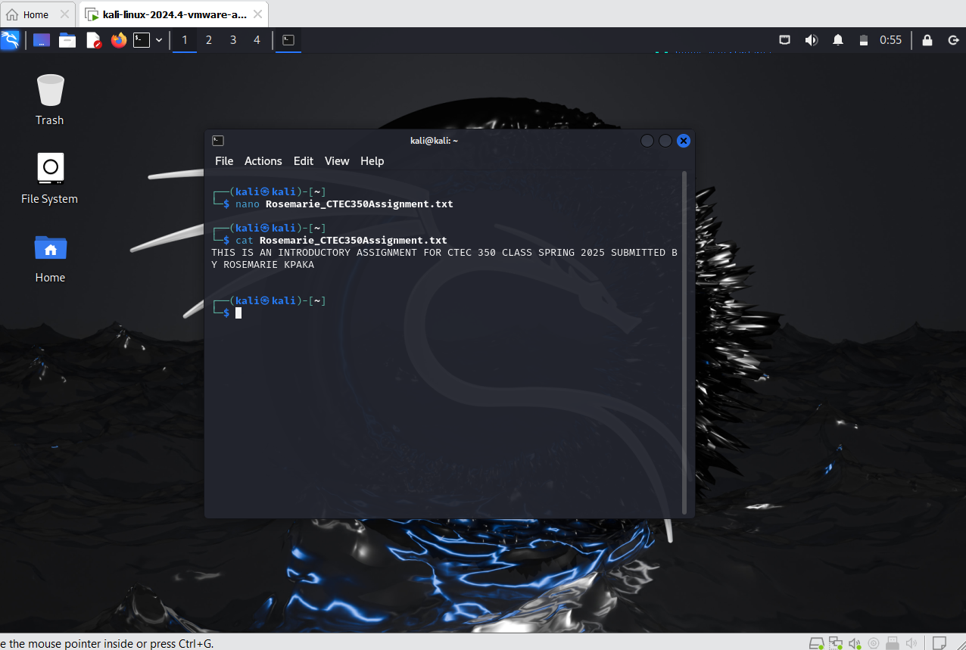

* New Step 8: Retrieving System Information
  + Use the uname command to retrieve basic system information:
    - uname (print system information)
    - uname -a for all available system information including kernel name, network node hostname, kernel release, kernel version, machine hardware name, processor type, hardware platform, and operating system.
  + Discuss the importance of understanding the system you are working on, especially in contexts where multiple Linux distributions might be in use.

Knowing your system's details is essential, especially in environments with multiple Linux distributions. Different distributions may have variations in command behavior, file system structure, or available tools. Understanding the kernel version, hardware platform, and distribution helps troubleshoot issues, ensure compatibility with software, and optimize performance.

* + Retrieve network information:
  + Use ip addr show or the older ifconfig (if installed) to display network interfaces and IP addresses.
  + Discuss how network configurations can affect system operations and connectivity.

Network settings directly influence connectivity, access to remote resources, and overall system performance. Misconfigured IP addresses, subnet masks, or gateways can lead to connectivity issues, limiting your ability to access the internet or local networks. Understanding network interfaces is crucial when diagnosing connection problems or setting up servers and services.

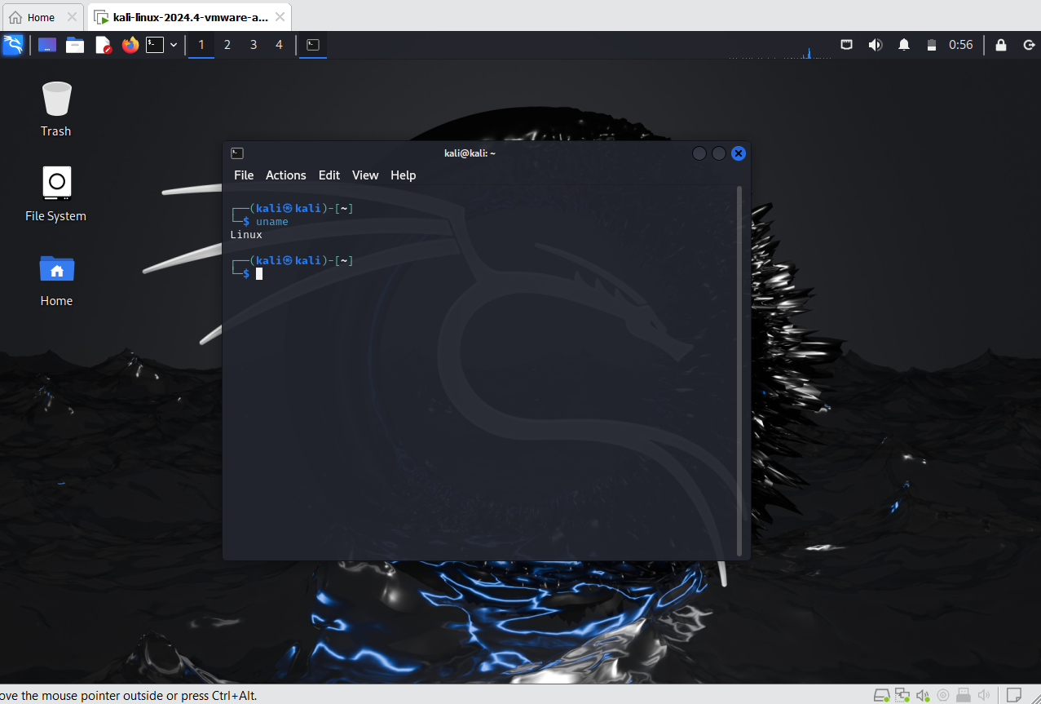

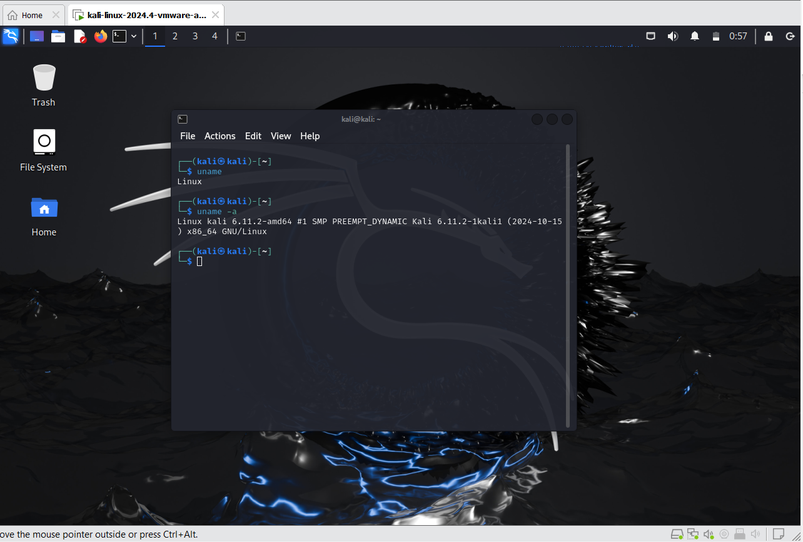

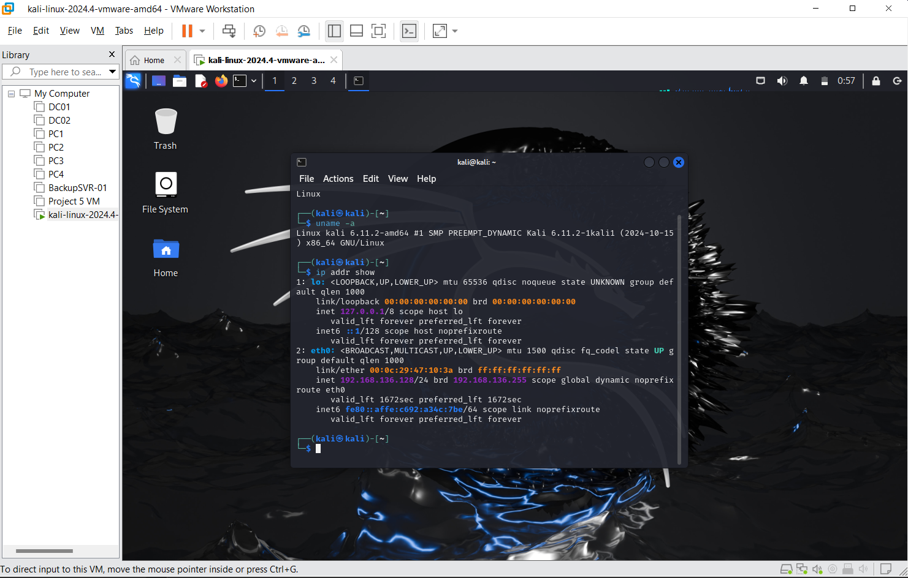

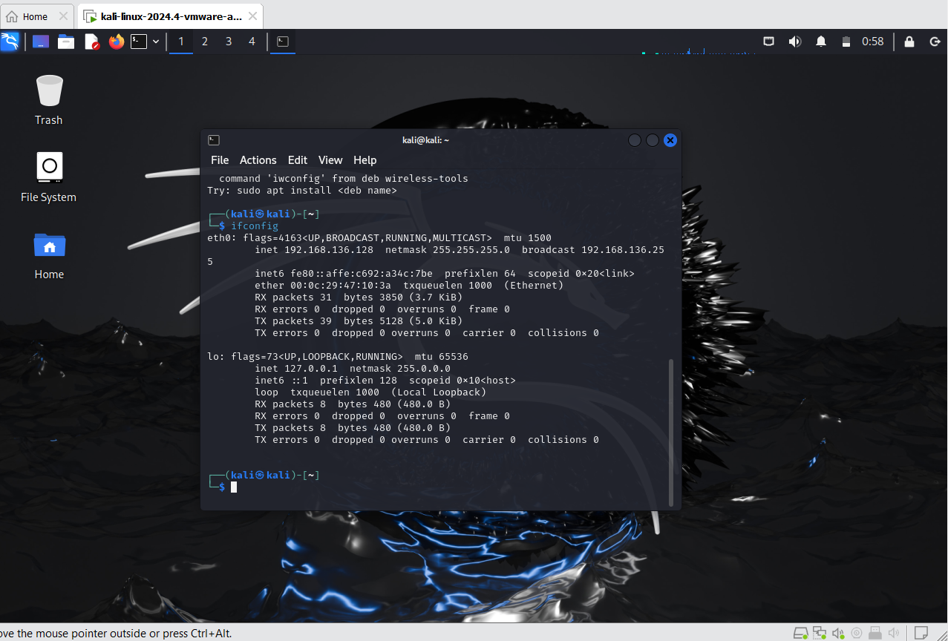

**Part 4: Understanding Permissions, Users, and Basic System Monitoring**

* Step 9: File Permissions and Ownership
  + Discuss the importance of file permissions in Linux.

Linux uses a robust permission system to control access to files and directories. Permissions determine who can read, write, or execute a file, enhancing security and preventing unauthorized modifications.

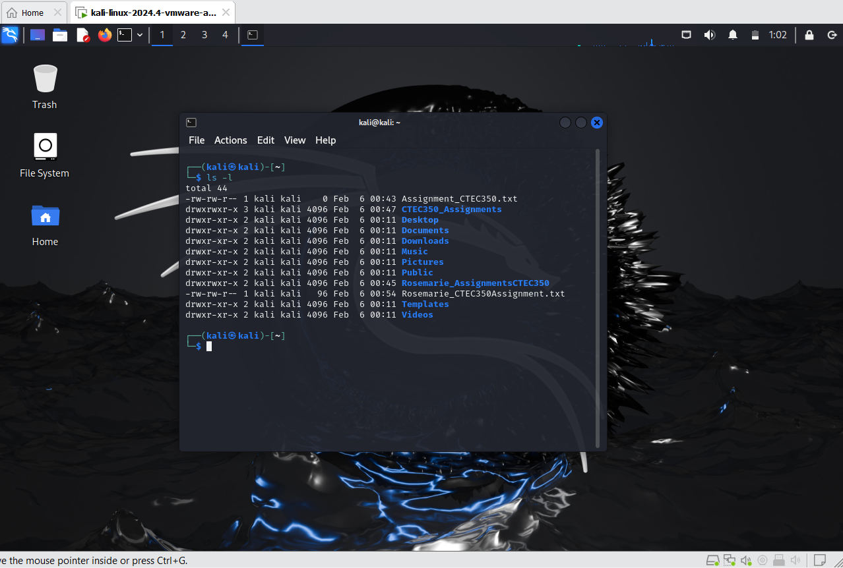

* + Learn how to view and modify file permissions:
    - chmod (change file mode bits)
    - chown (change file owner and group)
  + Change permissions of a file and explain the effect.

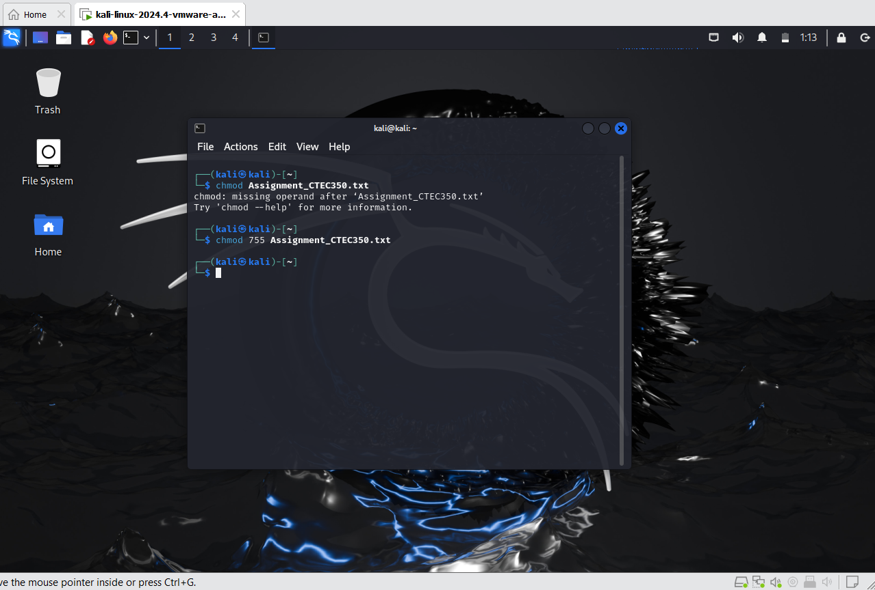

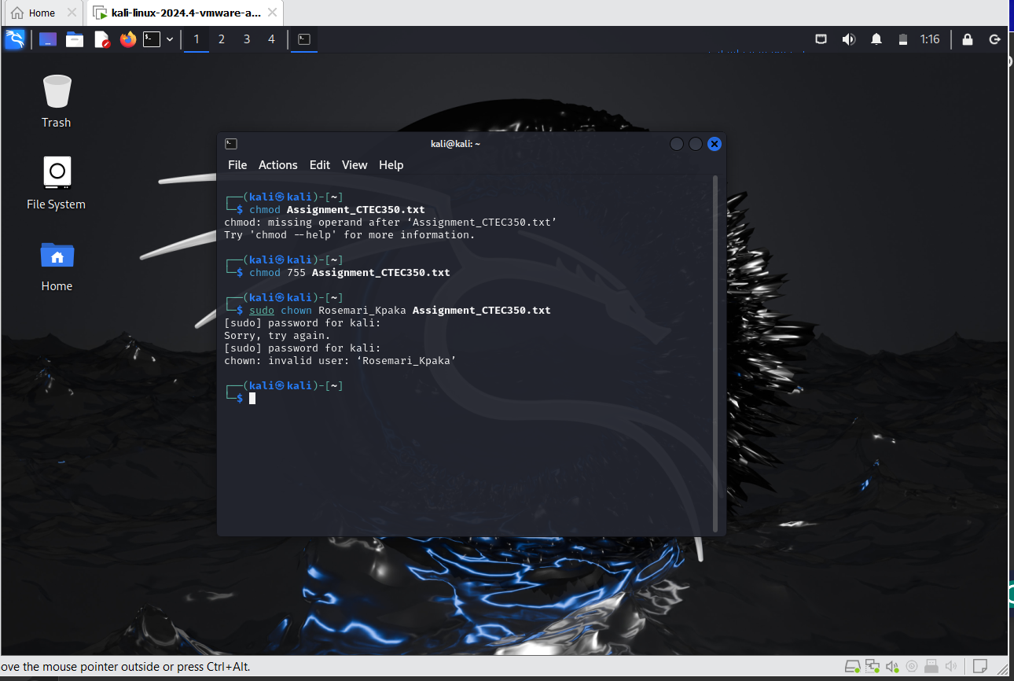

* Step 10: Searching and Finding Files
  + Introduce searching tools:
    - find (search for files in a directory hierarchy)
    - grep (search inside files)
  + Use find to locate files with specific criteria and grep to search for content within files.

